 Huxley Week 1
MONDAY | TUESDAY | WEDNESDAY | THURSDAY | FRIDAY
Pasta Bar  Freshly cooked pasta with a choice of sauce and toppings including cheese, ham, tuna and sweetcorn  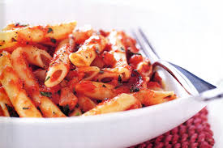 | 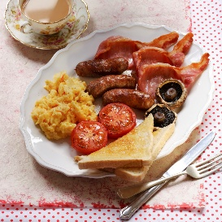  All Day Breakfast  Choose from a butcher’s quality sausage, bacon or a Quorn sausage, served with scrambled egg, mushrooms, baked beans and buttered bread | Pizza  Margarita served with sweetcorn and pasta spirals   | 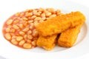  Fish & Chips  Breaded Fish Fingers baked and served with chips and peas or baked beans | Baked Potato  Choose Tuna, Cheese or beans  Toasted Panini or  Sandwich  Choose Tuna, Cheese or Ham  All served with fresh salad  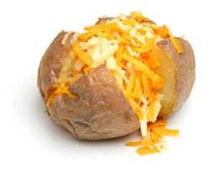
Jacket Potatoes and a selection of sandwiches are available daily as hot and cold alternatives
Desserts
Fresh Fruit is available daily along with the dessert of the day freshly baked
Drinks
A selection of juices and water will be served daily

MONDAY | TUESDAY | WEDNESDAY | THURSDAY | FRIDAY
Pasta Bar  Freshly cooked pasta with a choice of sauce and toppings including cheese, ham, tuna and sweetcorn | 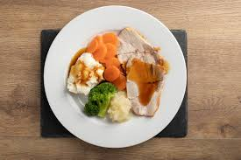  Roast Dinner  Chef’s home roasted joint of the day, served with potatoes, vegetables and gravy | Fajita’s  Fresh strips of chicken cooked with onions and peppers in a mild fajita spice, served in a tortilla wrap with rice and salad  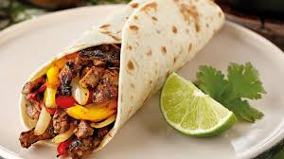 | 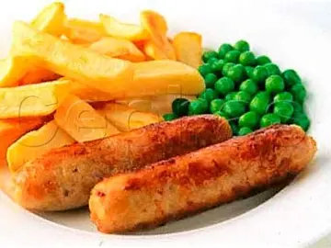  Sausage and Chips  A butcher’s sausage baked in the oven and served with chips, peas & gravy | Baked Potato  Choose Tuna, Cheese or beans  Toasted Panini or  Sandwich  Choose Tuna, Cheese or Ham  All served with fresh salad  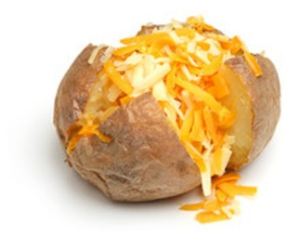
Jacket Potatoes and a selection of sandwiches are available daily as hot and cold alternatives
Desserts
Fresh Fruit is available daily along with the dessert of the day freshly baked
Drinks
A selection of juices and water will be served daily
Huxley Week 2

MONDAY | TUESDAY | WEDNESDAY | THURSDAY | FRIDAY
Pasta Bar  Freshly cooked pasta with a choice of sauce and toppings including cheese, ham, tuna and sweetcorn | 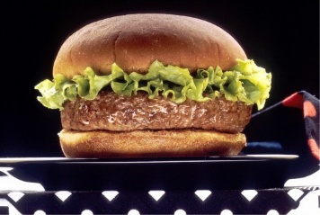  Beef Burger  A fresh butcher’s burger served in a bun with homemade potato wedges, salad or beans | Spaghetti Bolognaise  Mince beef cooked with onions, garlic, tomatoes, mushrooms and herbs. Quorn option available. Served on a bed of spaghetti with broccoli  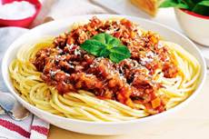 | Fish & Chips  Breaded Fish Fingers baked and served with chips and peas or baked beans | Baked Potato  Choose Tuna, Cheese or beans  Toasted Panini or  Sandwich  Choose Tuna, Cheese or Ham  All served with fresh salad
Jacket Potatoes and a selection of sandwiches are available daily as hot and cold alternatives
Desserts
Fresh Fruit is available daily along with the dessert of the day freshly baked
Drinks
A selection of juices and water will be served daily
Huxley Week 3

MONDAY | TUESDAY | WEDNESDAY | THURSDAY | FRIDAY
Pasta Bar  Freshly cooked pasta with a choice of sauce and toppings including cheese, ham, tuna and sweetcorn | Roast Dinner  Chef’s home roasted joint of the day, served with potatoes, vegetables and gravy | Noodle Bar  Chef’s noodle dish of the day  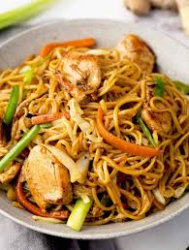 | 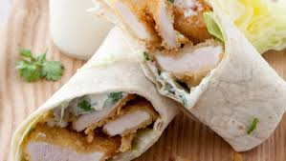  Chicken Wrap & Chips  Served with beans or peas and salad | Baked Potato  Choose Tuna, Cheese or beans  Toasted Panini or  Sandwich  Choose Tuna, Cheese or Ham  All served with fresh salad
Jacket Potatoes and a selection of sandwiches are available daily as hot and cold alternatives
Desserts
Fresh Fruit is available daily along with the dessert of the day freshly baked
Drinks
A selection of juices and water will be served daily
Huxley Week 4

